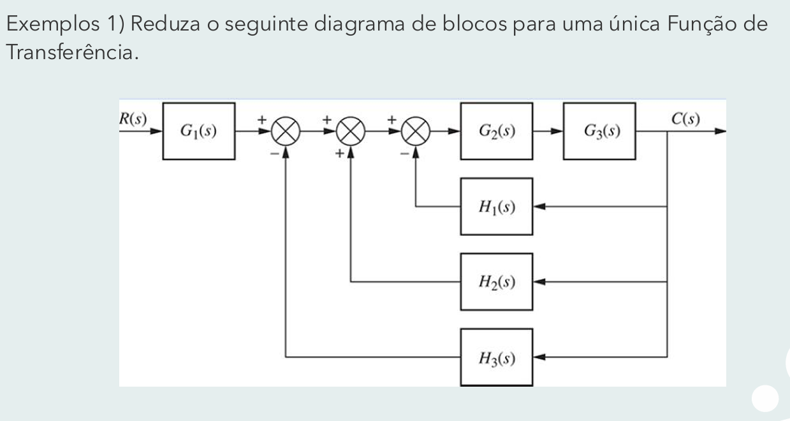
Reorganizando o diagrama obtemos:
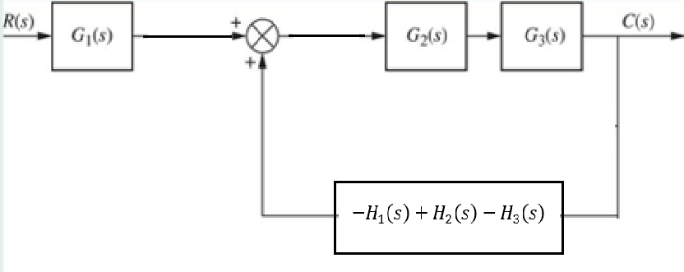
$$[RG_{1}+C\left(-H_{1}+H_{2}-H_{3}\right)]G_{2}G_{3}=C$$
$$RG_{1}G_{2}G_{3}+C\left(-H_{1}+H_{2}-H_{3}\right)G_{2}G_{3}=C$$
$$RG_{1}G_{2}G_{3}=C-C\left(-H_{1}+H_{2}-H_{3}\right)G_{2}G_{3}$$
$$\frac{C}{R}=\frac{G_{1}G_{2}G_{3}}{1-\left(-H_{1}+H_{2}-H_{3}\right)G_{2}G_{3}}$$
$$\frac{C}{R}=\frac{G_{1}G_{2}G_{3}}{1+\left(H_{1}-H_{2}+H_{3}\right)G_{2}G_{3}}$$

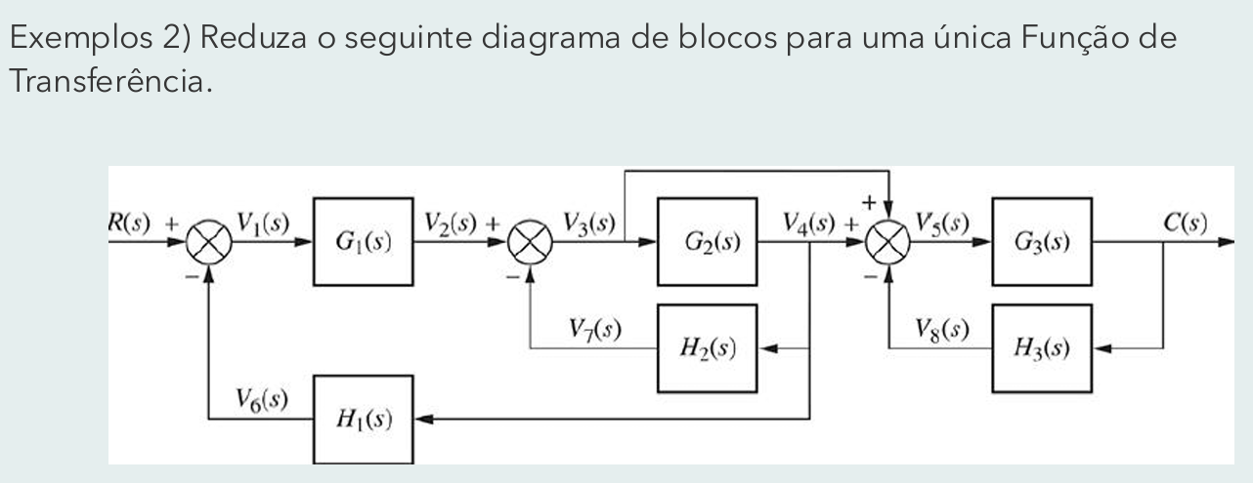
$$Type equation here.$$

Depois de matemágica, resultado é

$$\frac{C\left(s\right)}{R\left(s\right)}=\frac{G_{1}G_{3}\left(G_{2}+1\right)}{\left[1+G_{2}H_{2}+G_{1}G_{2}H_{1}\right]\left[1+G_{3}H_{3}\right]}$$

